C) Describe the theory and practice of motors and motor control, including electromagnetic theory, PID control, and embedded systems used in a real application.

Electromagnetism describes one of the fundamental forces of nature. This force is between subatomic particles called protons and electrons and the force also helps to hold matter together.

Electromagnetism can also describe how a magnetic field is created by the flowing of electric current. In a simplest example, when an electronic current flows through a wire it generates a magnetic field. This magnetic field can be increased by coiling the wire, thus allowing more current to flow through because of the reduced distance and resulting in a magnified magnetic field [1].

The right-hand rule is used to tell the direction of current and orientation of a magnetic field when a current (I) is flowing through a wire. The magnetic field (B) rotates around the wire and the direction of the current determines the direction of the magnetic field. As shown in figure 1

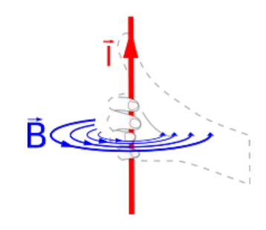

1. Showing how the right-hand rule is used to find direction of current and orientation of magnetic field. Taken from a website called Physics for kids

Electromagnetic theory is therefore comprised of:

Charged Particles (protons and electrons) and the electric and magnetic fields E and B, which are vector quantities that depend on position and time.

An intrinsic quantity analogous to gravitational mass is the charge e of a particle which can be positive or negative. This charge determines the strength of the particle’s interaction with electrical and magnetic fields so much as the particle’s mass determines the strength of the interaction with gravitational fields. The interaction occurs in two directions. The electrical and magnetic fields exert a force on a charged particle which depends on the value of the charge, the particle’s velocity and the values of E and B at the location of said particle. This can be defined as a formula called Lorentz-force law [2].

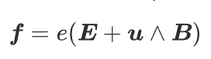

1. Lorentz force law formula

Where e is the charge and u is the velocity, again, analogous to gravitational force.

F = mg

On a particle of mass m in a gravitational field g. In principle, an observer can measure the electric and magnetic fields at a point (by measuring the force on a standard charge with a known velocity), only through the force law. [2]

Looking at the electric forces and Magnetic forces in a slightly different equation representation

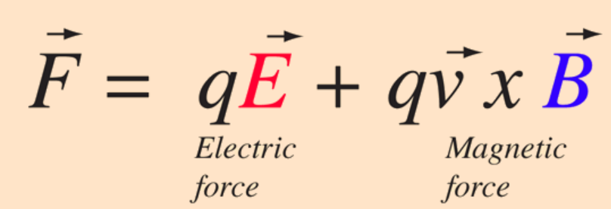

1. Lorentz force law formula written to show the direction of Force and Magnitude

The electric force is straight forwards since it is in the direction of the electric field if the charge q is positive but for the direction of the magnetic field the right-hand rule must be used yet again [3]. 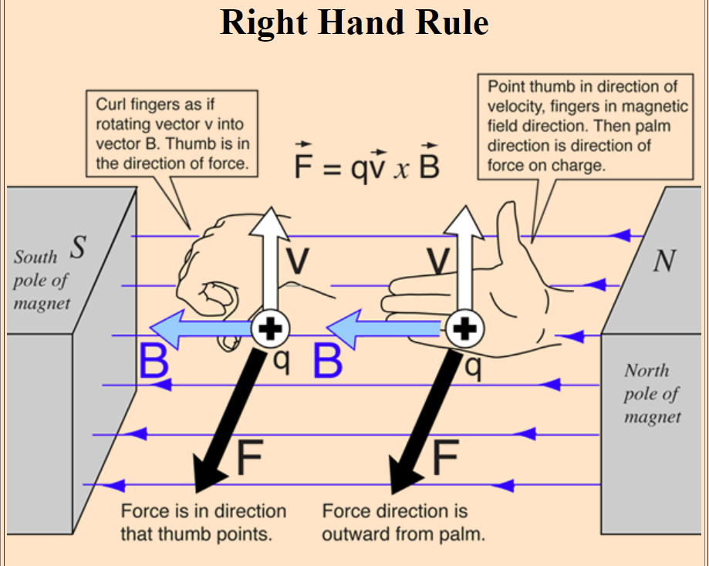

1. Right hand rule showing direction of current and magnetic field

Electric motors are designed based on this principle. An electric motor converts energy into physical movement. And generate magnetic fields with electric current through a coil. The magnetic fields cause a force with a magnet that causes movement or spinning that runs the motor.

They are designed to enable linear or rotary motion by producing a mechanical power through electricity, hydraulic power, thermal power, steam, gas etc. Electric motors can be classified into two different kinds according to the type of the power source used. Direct current (DC) or alternating current (AC). Brushless DC motors are a hybrid of the two that combine a permanent magnet synchronous Motor utilised by AC motors, with the electrical characteristics of a DC Motor. The first electric motor built was inspired by Michael Faraday’s discovery of electromagnetic induction in 1831[4].

Traditionally, DC motors have been used widely for speed and position control applications because of the ease if their torque control and excellent drive performance. Induction motors have been widely used for general purpose in constant-speed applications due to their low cost and rugged construction.

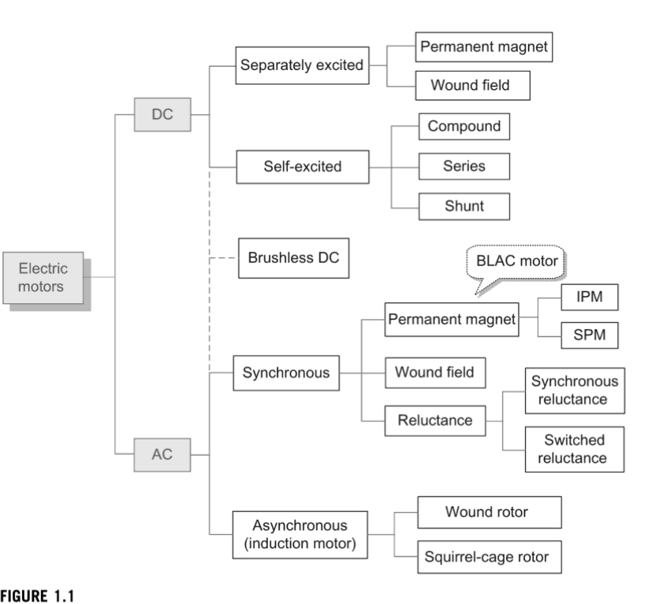

1. Diagram from book on Electric motor control

Implementing PID for robot

To control the robot with a joystick I implemented a closed loop PID solution that took as input the voltages from a joystick within the ranges of angle theta to 360 and converted that to a velocity for each of the four motors. I then had that mapped as my ultimate desired voltage and compared it to the current voltages that each of the motors received. The error was the result of the difference between the speeds each motor was receiving, the (actual speed) and the speed I was giving from the joystick, my reference at each position theta.

A PID controller is a device that takes in the error and converts it into command that is then feedback into a control system.

I wanted to reduce the error, (difference between desired and actual speed values) for the robot as much as possible to improve the robot’s responsiveness to the joystick.

First, I started by setting all three PID values Proportional, Integral and Derivative to zero and slowly modified each one to see the result of minute changes to each value on the reduction of the error in the Serial plotter.

For Proportional, I set a constant variable Kp and multiplied the error by kp to see the output, for Integral, I multiplied the error by a similar constant Ki and then integrated. And lastly for the Derivative I multiplied the error by constant variable Kd and then differentiated. The output of these three gain values were then summed together to create an output for the robot.

I changed each of these values slowly because I wanted to find the best set of gain values for the system, we had set up by adjusting how sensitive the system was to each of the inputs. In the Serial Plotter the error in the system changes over time in the figure below. When only P was modified, the output showed how the error was scaled by Kp. When the error was large the Kp value produced a large output, and the error was zero the output in the path was 0 and when the error was negative the output was negative. I tried to make the error as close to 0 as possible via Kp alone. I then moved onto Ki. When only Ki was modified, the output showed that as the error changed over time the error was summed up and multiplied by constant Ki. It was necessary to modify Ki because it removed constant errors in the control system because even when the error was small, the summation of the error would eventually get too high and affect the output going to the motors. And When only D was modified, the output showed how modifying Kd affected the rate of change of the error. The derivative was small when the error value did not change too often. However, when the error started changing at a faster rate, the derivate also grew larger. I found that the system worked best when ki was set to a larger value say 5 and kd and kp were set to a low value such as 1. This was because the input from the joystick was so erratic that the error was constantly changing and thus Ki was the most important parameter to tune. To read and modify the output for the PID controller at run time timer interrupts were used to allow readings of the motor and joystick to be taken at certain times independent of the section of code that was currently being executed. This was done my momentarily pausing the section of code running at the given time interval and then reading the values before carrying on executing the code

2

a) Differentiate between open-loop and closed loop control systems

The main difference between an open-loop system and a closed-loop system is closed loop control systems can self-correct whereas, open-loop control system cannot. Closed-loop systems are often referred to as feedback control systems and open-loop control systems are referred to as non-feedback controls [5].

b) Critically analyse the working, pros and cons of Proportional (P), Proportional-Integral (PI) and Proportional-Integral-Derivative (PID) controllers.

Below is an image of a PID type controller being used to control a motor. This is an example of a closed loop control system and the benefits of this are that there in finer control of what the output of the motor will be. Cons of this are that PID controllers require a lot of tuning. Each parameter kp, ki and kd needs to be be manipulated. If they are not, then the system because equivalent to the parameters that are tuned. I.e if Only the Kp values of a controller are tuned, it becomes a P controller. This is beneficial for systems that only have large errors to be corrected. Because only one parameter is being tuned these systems are much faster and easier to deal with. When the Kp and Ki parameters are tuned the system becomes a PI controller. This is necessary for systems that not only have large errors to be corrected but also systems with lots of errors over time as these errors can build up and affect the output of a P control system. PI controllers are more complex than P controllers due to the added parameter to tune but they do offer better control of the system’s output as a result. Lastly, PID controllers are necessary for systems that have lots of large errors, that have a high rate of change such as in a radio controller. PID controllers are again, more complex than the previous two controllers to tune but they offer a greater level of control because of the ability to handle multiple changing errors in a system.

For controlling a motor such as the one below the best controller would be the one best suited for the job the motor is required to do. If the motor were connected to a slow printing 3D printer pinhead printing a simple block then the P controller would be the best because errors would only occur when trying to place the pin head at the right axis and because the printer is printing slowly, it is printing a simple object and therefore there would not be many errors from it moving while printing and lastly because it is moving slowly errors wouldn’t change very quickly either.

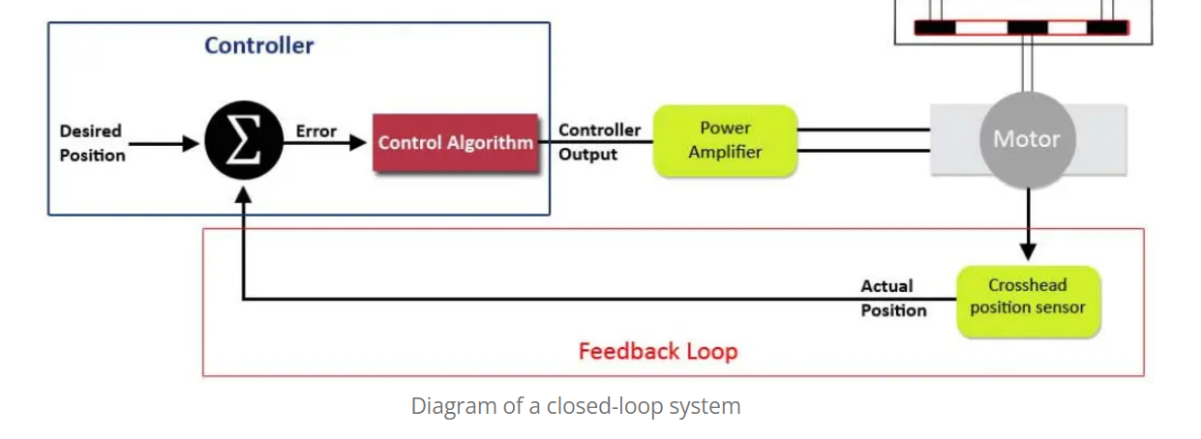

1. Image taken from Open and Closed-Loop Systems in the Materials Testing Industry

(c) Select a suitable controller to control the speed of individual wheels of a wheeled mobile robot. Briefly explain the rationale behind selecting this controller for this application. Explain this control algorithm using pseudo-code and graphical representation(s) of the controller’s response.

For controlling the speed of individual wheels on a mobile robot a PID controller would be the best

option. This is because a mobile robot is likely to need to be able to move fast and therefore the rate of change of errors would be very frequent as the robot is moving around. In addition, because the robot would need to be mobile in the first place, this would mean that each time it takes an action there is a chance of an error due to slippage, friction, surface of the ground and other real world elements, as a result of this there would definitely be many errors in the control system.

3

a) Appreciate the use of a map of the environment while working with an autonomous mobile robot. Discuss any one of the commonly used map representation in mobile robotics.

One of the commonly used maps representations in mobile robotics are probabilistic maps. On a grid each cell is assigned a probability to be occupied and the cells without numbers are assumed to be empty, so are set 0. The benefits of probabilistic maps are that they are more accurate than continuous maps which are only good for few and simple objects. In addition, because each cell is associated a probability, they also have less memory requirements than Discrete Maps which grow increasingly memory intensive with map size and resolution. The drawbacks of Probabilistic maps are that because a threshold p\* ahs to be used to decide if an obstacle exists or not, the map can also end up being inaccurate

(b) Describe one of the existing approaches for mapping the environment using an autonomous mobile robot, with the help of pseudo code.

SLAM, Simultaneous Localisation and Mapping is one of the approaches that an autonomous robot may use to map an environment. For various reasons, a robot’s expected map may differ greatly from its perceived map. This could be because of avoiding an obstacle throws it off its map or slippage or encountering something that has been dynamically added on the map. To correct in such cases, the empty cells of both the perceived map and expected maps are set to -1 and occupied are set to 1 while unknown are set to 0. The similarities between the maps are then computed by multiplying the values of each corresponding cell and summing the results m is the expected map and p is the perceived.

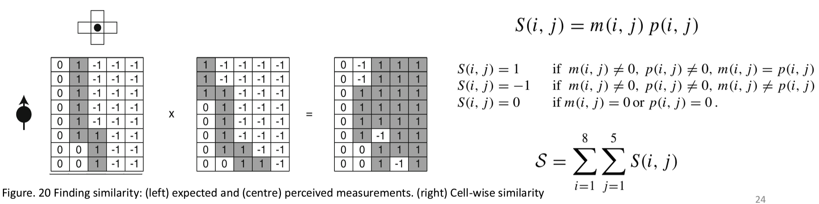

1. Taken from Gauthas Das’ lecture on Mapping

The expected map that best matches the perceived one will be used to correct the robot’s odometry and the expected map then becomes updated with the new observations accordingly.

SLAM mapping contrains three key stages:

* Move and sense
* Expected vs.perceived map
* Pose correction and map update

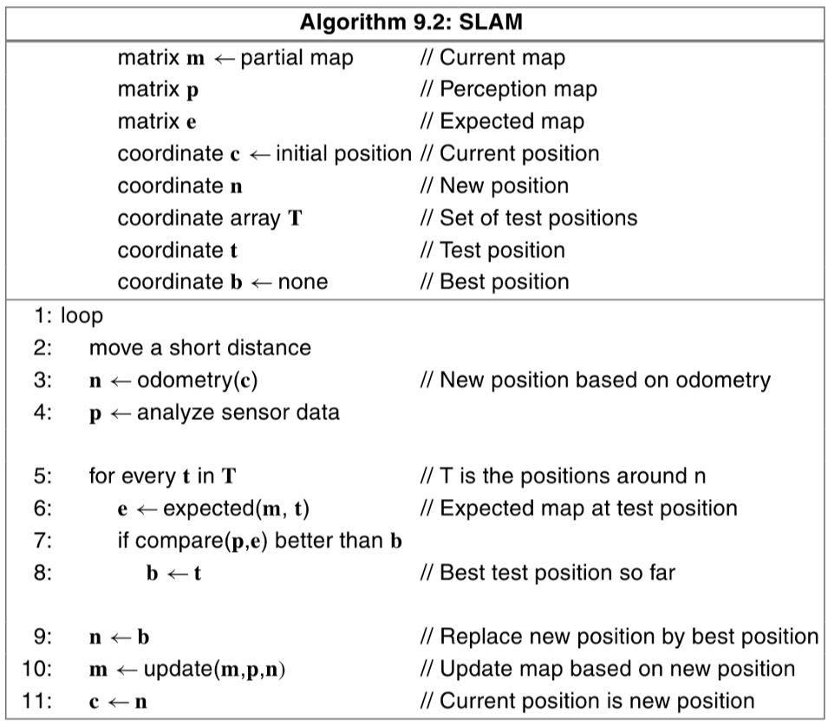

1. Taken from Gauthas Das’ lecture on Mapping

If we look at the above pseudo code then we can see that the robot starts by first moving around with odometry a short distance based on its current position and then comparing it’s new position after moving n on its perceived map p, with the position it should be at on the expected map e. Based on its perception if checks if any of the locations around its current position are better to be in than its current position. If this is the case it updates one of the positions around its new position as the best next location to move to in its current map. Finally, updates the current map as the best position it is now in given its perceived map and moves to that location.

(c) Assume a mobile robot is mapping an indoor environment shown in Figure 1. The objects in the environment are labelled in the figure. The environment is discretised into a grid of size 5 × 5, with each cell labelled as Cell(x,y), where x and y represent the column and row numbers of the cell as shown in the figure. The robot has eight on-board sensors to sense any occupancy in the eight neighbouring cells around it or any walls. The blue triangles represent the range sensing with on-board sensors. Also, assume the robot can move to any of the unoccupied neighbouring cells in a single movement. Describe how the algorithm you described in subquestion (b) will progress while the robot maps the full environment, starting from the given initial position.

1. Physics for kids. Electromagnetism and Electric Motors. Available at: <https://www.ducksters.com/science/physics/electromagnetism_and_electric_motors.php#:~:text=One%20of%20the%20important%20applications%20of%20electromagnetism%20is%20the%20electric%20motor.&text=Electric%20motors%20generate%20magnetic%20fields,in%20all%20sorts%20of%20applications>. Accessed [16/02/2022]
2. Carl S. Young. Electromagnetic Theory. 2016. Available at: <https://www.sciencedirect.com/topics/computer-science/electromagnetic-theory> Accessed [16/02/2022]
3. R. Nave Magnetic Force. Available at: <http://hyperphysics.phy-astr.gsu.edu/hbase/magnetic/magfor.html> Accessed [16/02/2022]
4. Kim, S.H., 2017. *Electric motor control: DC, AC, and BLDC motors*. Elsevier.
5. Denisz. Y. Open and closed-Loop Systems in the Materials testing Industry. 2017. Available at: <https://www.admet.com/open-loop-vs-closed-loop-systems-materials-testing-industry/#:~:text=The%20main%20difference%20between%20an,known%20as%20non%2Dfeedback%20controls>. Accessed[16/02/2022]